CST 4530 Lab Report

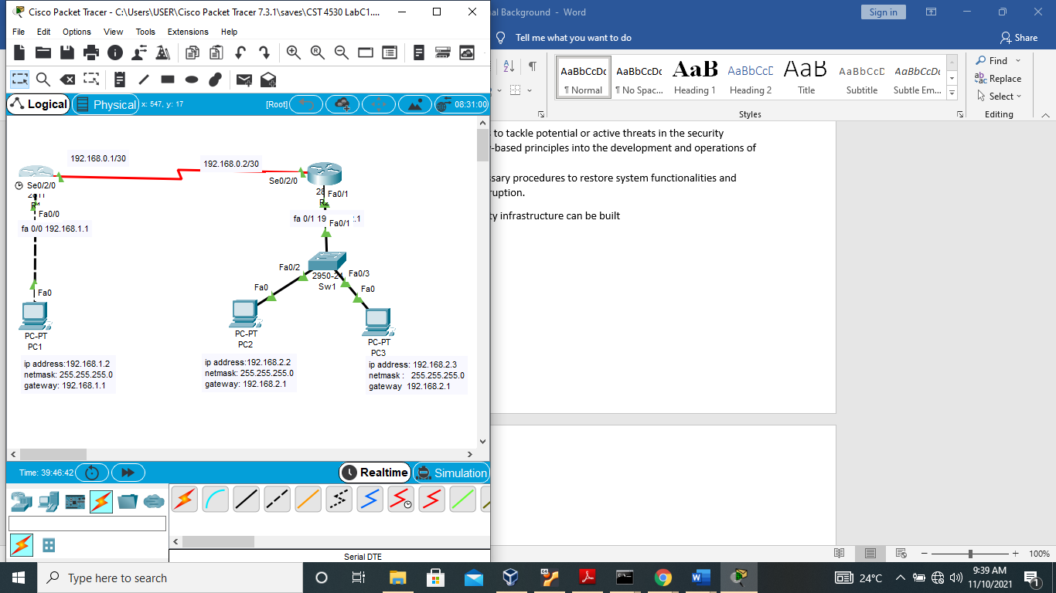

Steps taken to implement this network topology are as follows.

1. From the packet tracer dashboard, network devices were dragged and dropped. Two 2811 Routers named R1 & R2, a 2950-24 switch, and three end devices named Pc 1, Pc2, and Pc3 respectively.
2. A WAN module (WIC-1T) was added to the routers to provide serial connections to remote sites or legacy serial network devices.

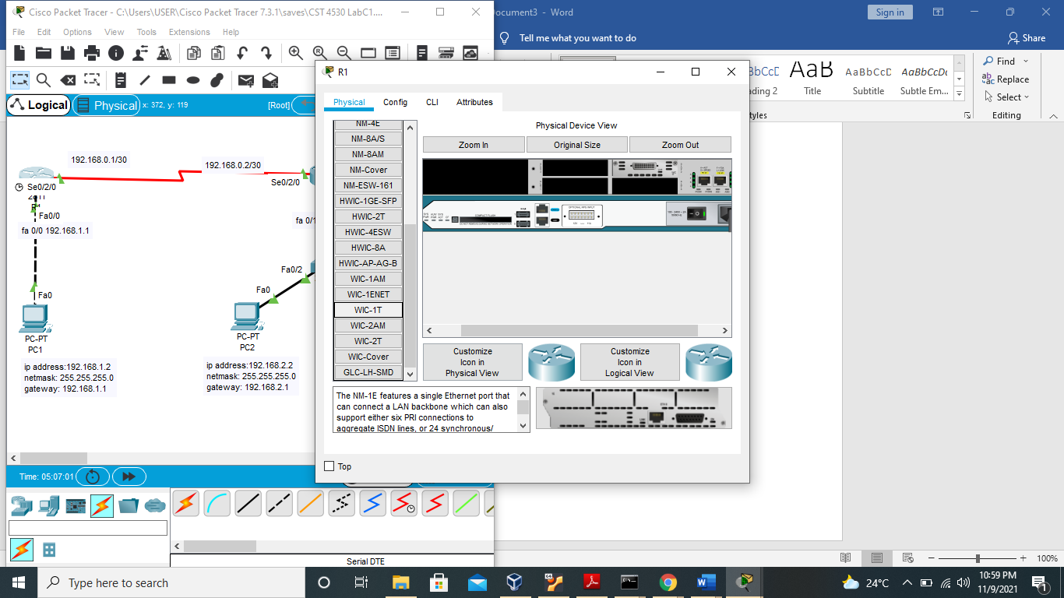

1. CONFIGURATIONS

End devices: PC 1,2 & 3 were each assigned IP addresses, netmasks, and default gateways as specified in the Lab manual

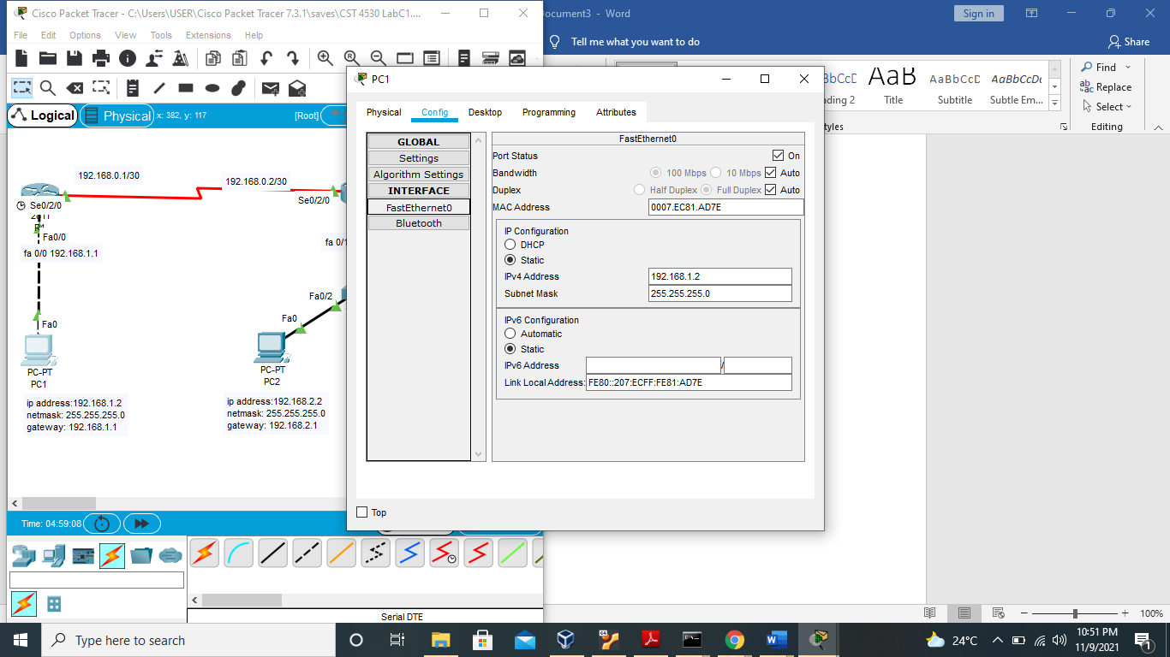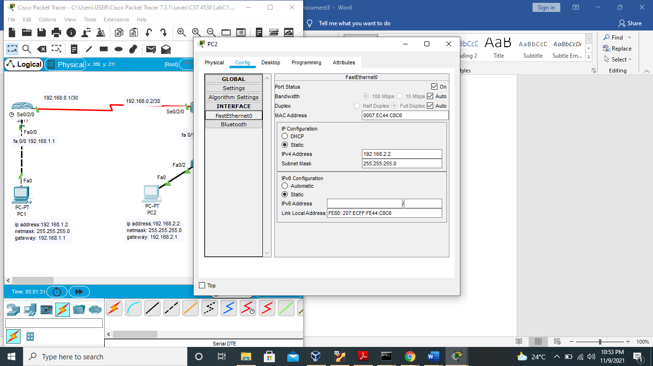

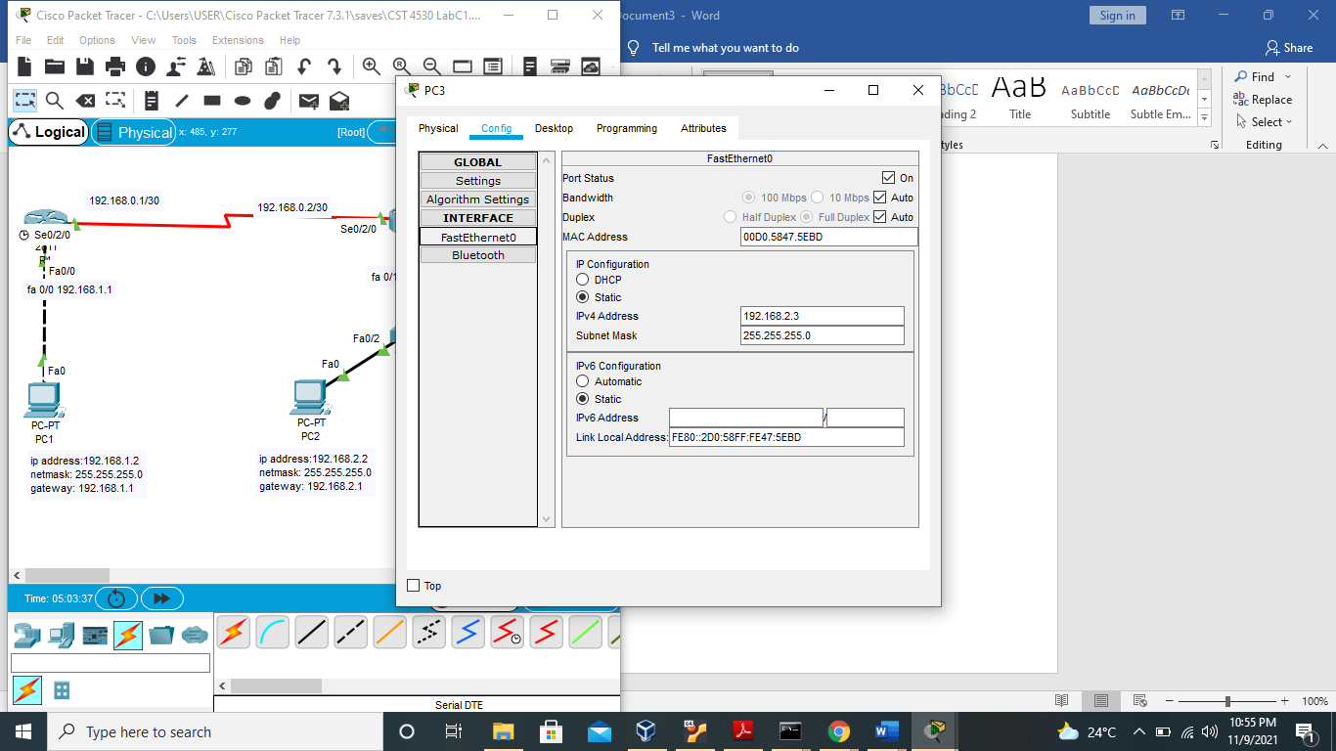

ROUTERS

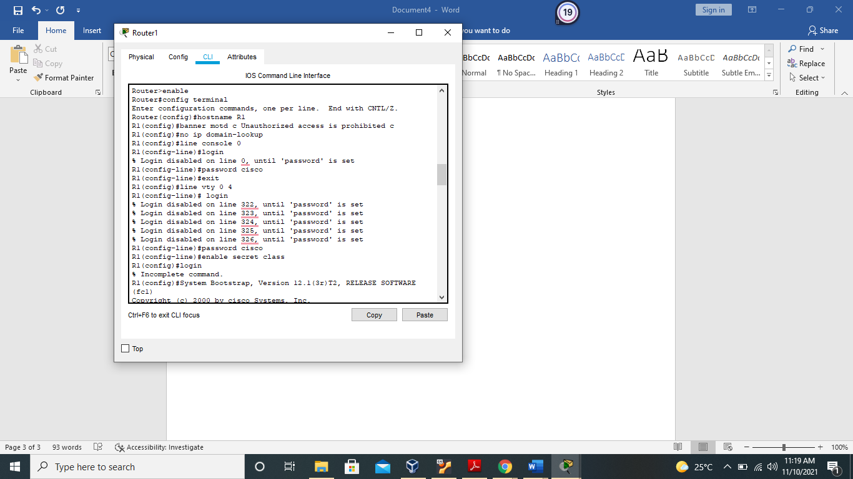

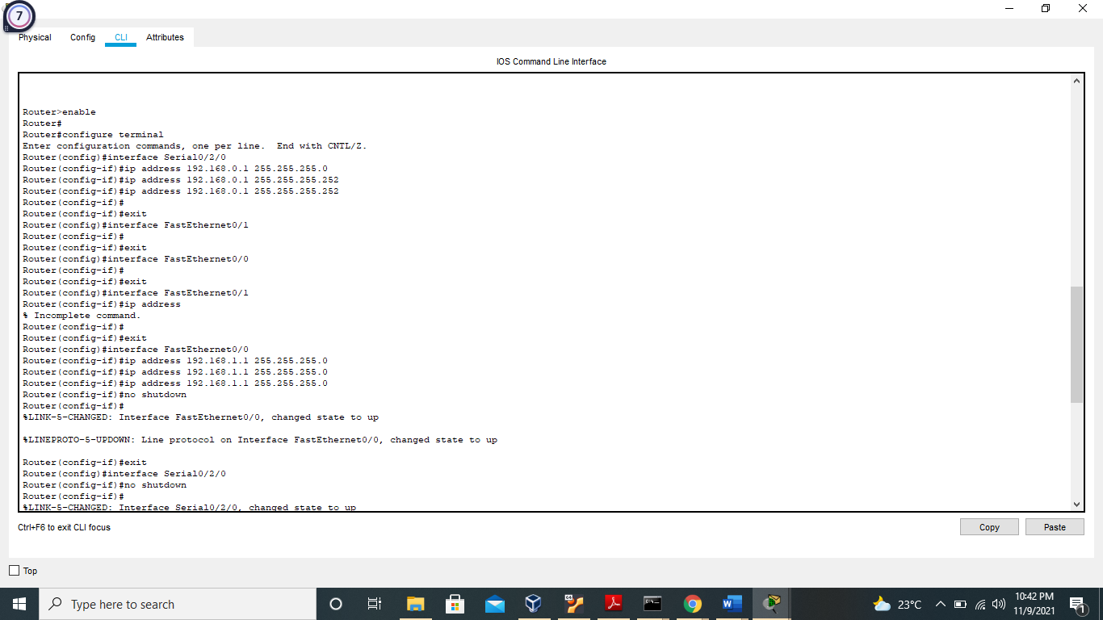

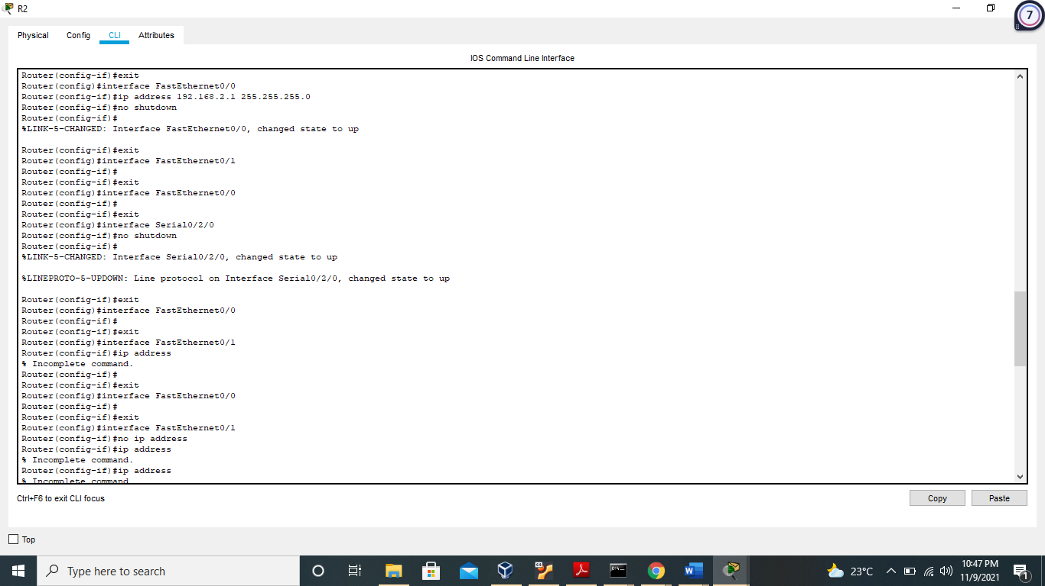

the screenshots above show the configurations caried out on the routers starting with enable command and switching to exec mode for advanced configurations. Note is taken of the change in mode between line console and privilege exec to interfaces. Depending on the command issued.

The following operations were carried out on the routers

* Change of hostname -R1, R2
* Fast ethernet configuration, Fa0/0, Fa0/1
* Serial configuration -S 0/2/0 on both routers
* The RIP protocol was configured to enable routers to learn about the network and IP addresses
* Set banner
* Vty line config for Telnet.

No configuration was done on the switch. Switch name was only changed to sw1.

Other operations performed on the network

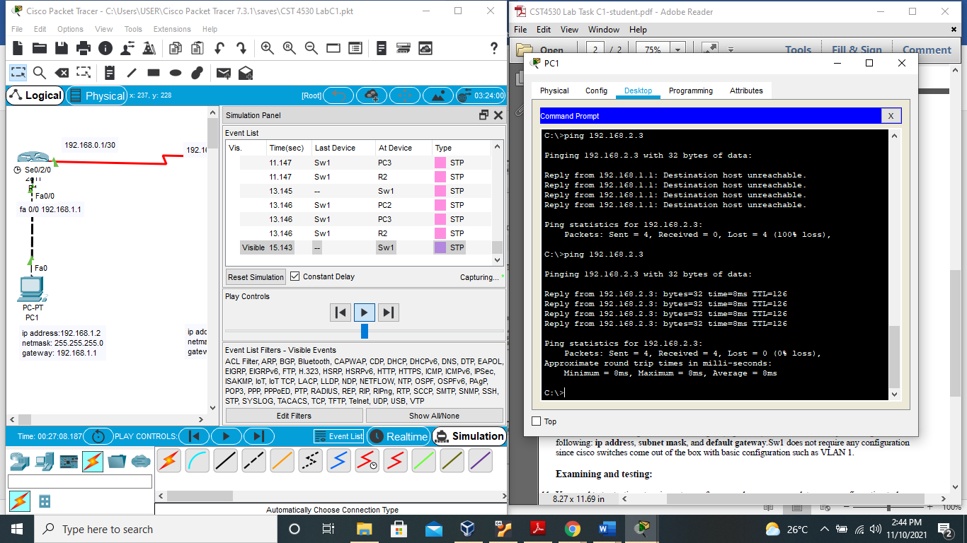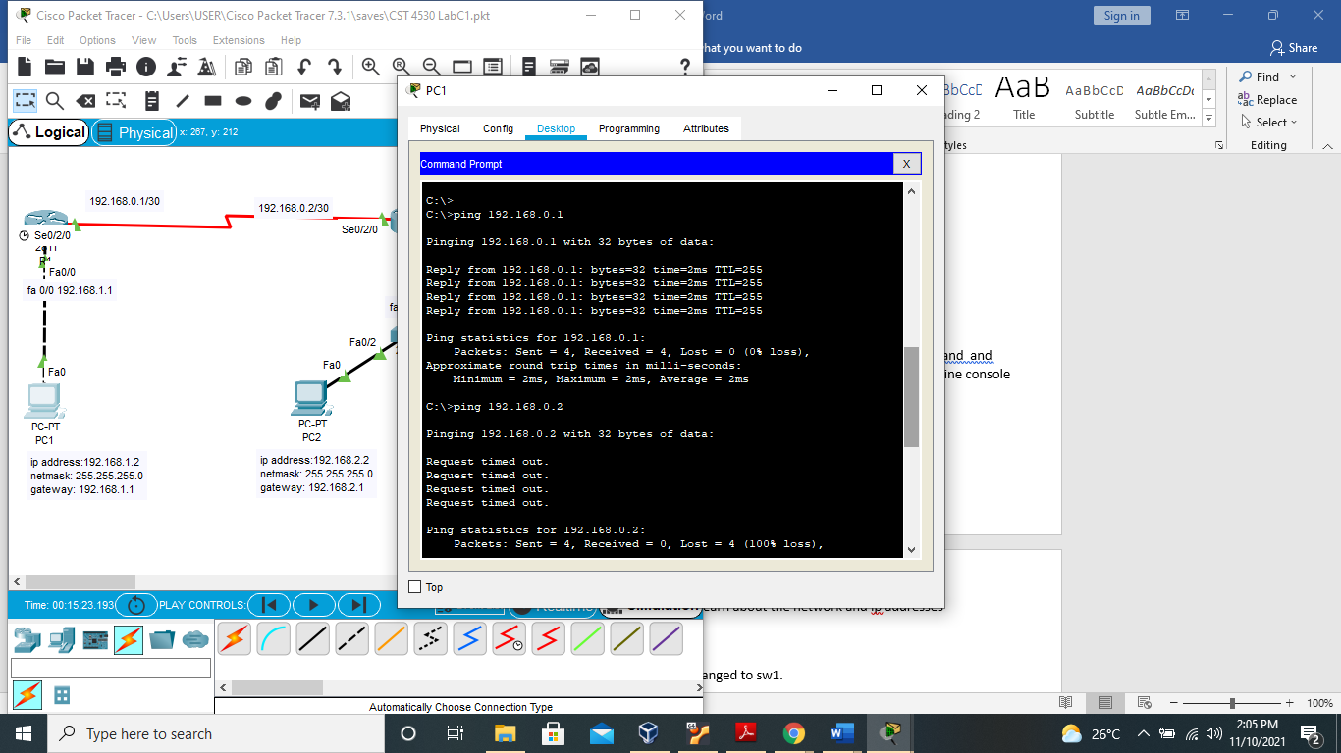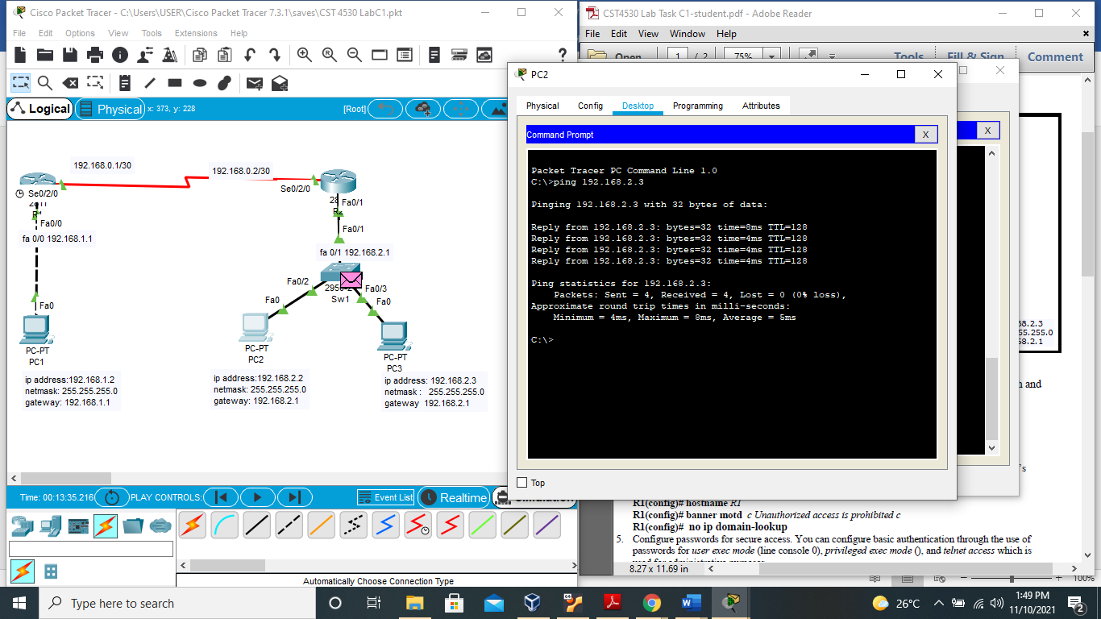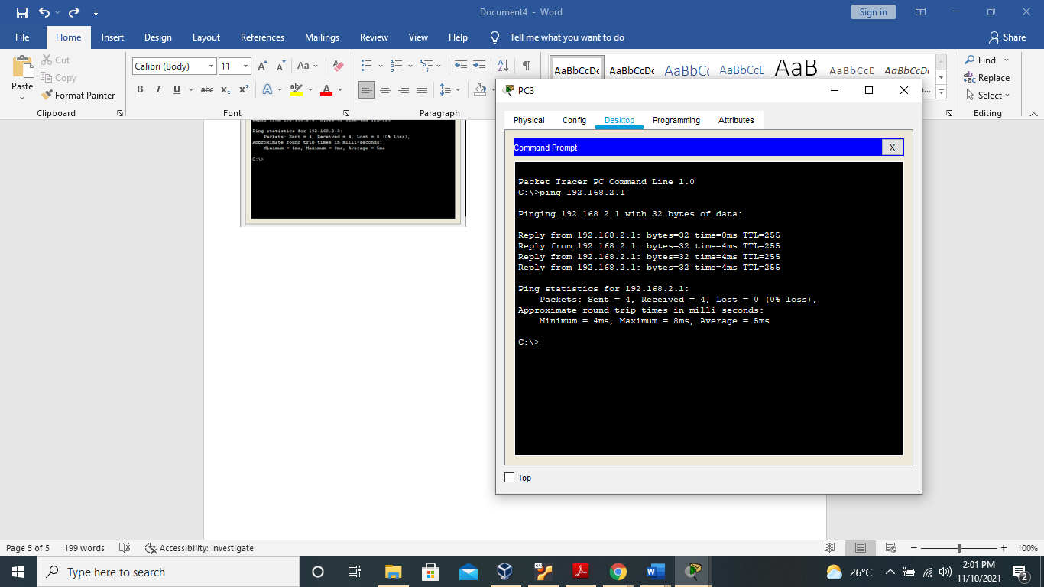

In the network above, end devices can ping one another and the switch/ router above them and all around the network

This is due to the RIP protocol implemented.

Show interfaces

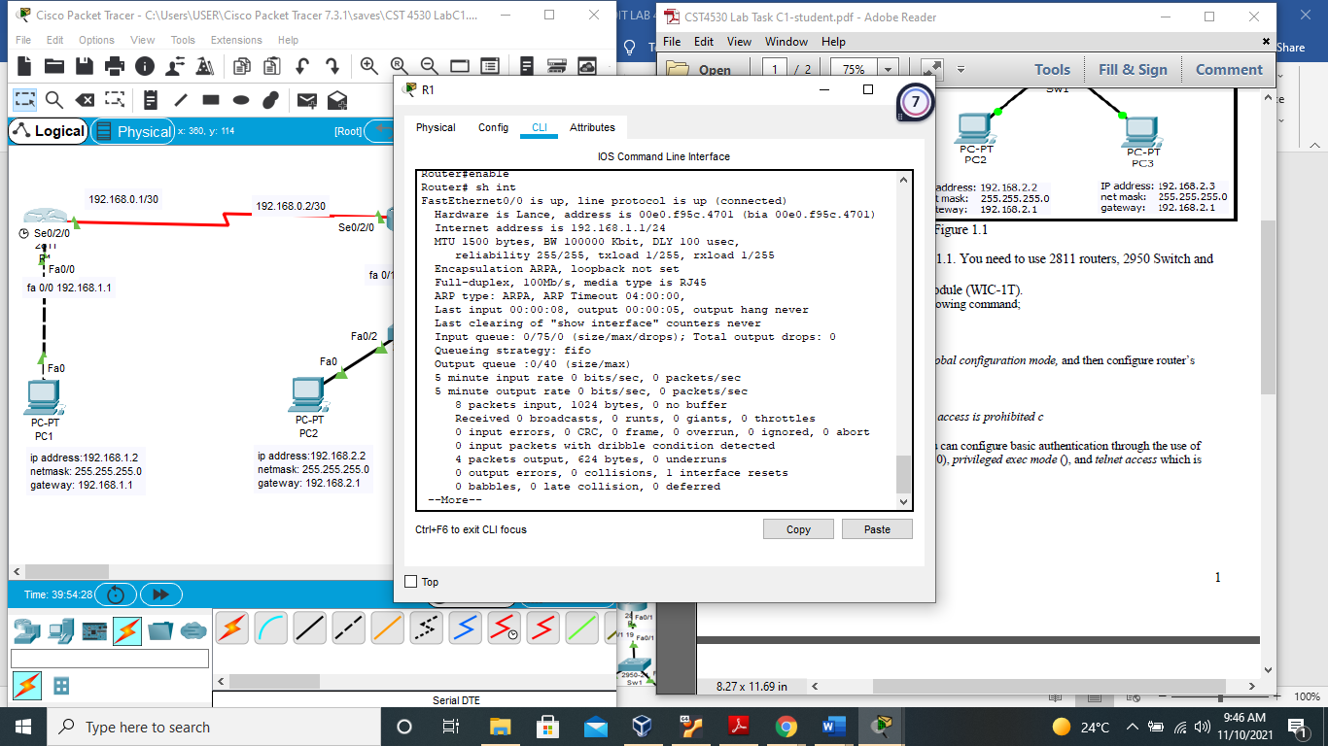

This shows the status and configuration of the network interfaces on the selected router.

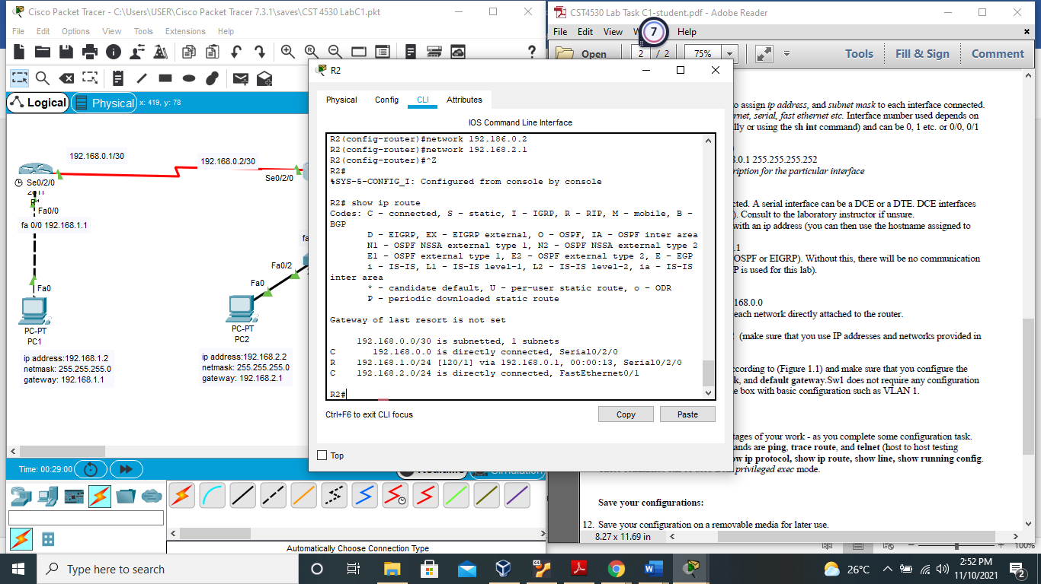

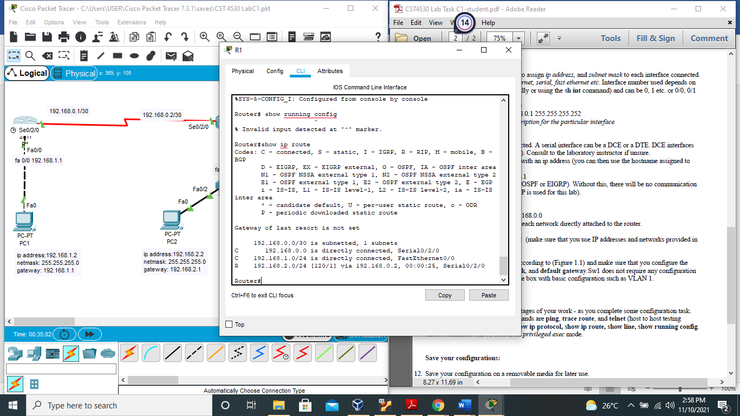

Ip route as seen in both routers above shows the network status as connected and the protocol used to learn about the network and IP addresses as Rip.